Learning SCORM and Tin Can API By David Rivers

<https://www.linkedin.com/learning/learning-scorm-and-tin-can-api/welcome?u=2045532>

SCORM (Shareable Content Object Reference Model)

It is a standard reference model or basically a set of instructions for the objects (courses and the components making up your courses) or pieces of content you want to share with others.

* It is a standard to allow the re-use to course and their components created with SCORM compliance applications to be published on LMS. It does not provide API access, but it a tool to publish courses on LMS.
* A course will be published (converted to a SCORM compliance file), this file can then be imported into the LMS to create a course.
* SCORM compliant e-learning content can be reused in a variety of systems and frameworks, removing the need to duplicate content across different e-learning applications and LMS vendors.
* And your courses will be able to withstand changes in technology without the need to redesign, reconfigure, or recode them.
* By creating SCORM-compliant courses, we can be confident our content will work with any LMS.
* After turning on options in your software to ensure SCORM-compliance, your course is broken up into Shareable Content Objects (SCOs) that will communicate with any LMS.

Most e-learning software is SCORM compliance.

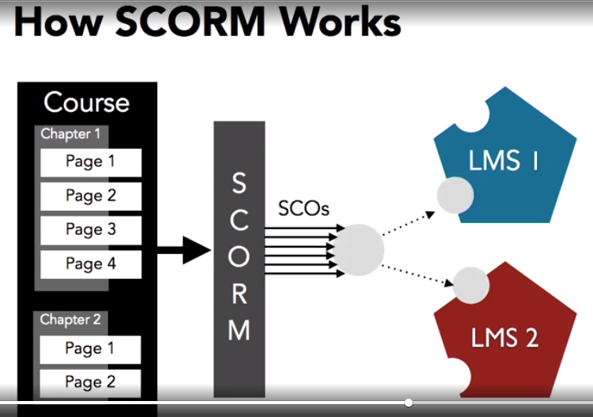

* Create a course
* Make the course SCORM compliance
* Publish the course into the LMS
* Create a second course
* Reuse chapters, pages, or components from the first course into the second course

Applications used to create SCORM compliance courses

* Adobe Captivate
* Articulate Storyline 2
* Lectora Inspire
* Camtasia

PROCESS OF CREATING AND PUBLISHING A SCORM COURSE:

=============Course App==================== ===================LMS==========

Create course -> Export -> Enable Reporting ->

SCORM compliant -> course ID -> Save as File -----------> LMS -> Create course with ID -> Import

From SCORM file

Requisites of a SCORM Compliance’s course

* It must have a student’s interaction (Quiz, question)
* Coordinate the quiz score between course and the LMS, either “for credit” or “not for credit”, or “scored in percentage” or “scored in points (1 out of 10, 70 out of 100)”

Tin Can API (Aka Experience API or xAPI):

It is the next generation SCORM standard.

xAPI operates is based on activity streams, which is a model that uses software to track what people are doing.

Advantages of Tin Can API:

* It is not limited to Elearning or LMS
* It describes interfacing with any software with any type of reporting system
* It allows for the tracking of all kinds of learning activities, not just courses and scores. It's not limited to the use of learning management systems. Those activities include performing work-related tasks, producing work-related outputs, interfacing with others using social media, achieving milestones in games or simulations, and just about any other activity that can be observed or recorded.
* It used “Activity IDs” instead of “Course IDs” used in SCORM

Learning Record Store (LRS):

xAPI will make use of an LRS for storing a learner's learning records.

an LRS is the database where these xAPI activity statements are stored for each individual learner.

With xAPI, anything a learner does as part of a learning program, generates an xAPI activity statement.

An LRS can be embedded into a LMS or it can be a stand-alone service.

Moodle

A Moodle’s plugin is used to upload a xAPI course

See: <https://www.youtube.com/watch?v=qJxO4Ene2kM>